

**Public Law Child Care Solicitors Panel**

**Terms and conditions**

**Effective 1st October 2022**

Table of contents

**Public Law Child Care Solicitors Panel Terms and conditions** 4

Introduction 4

Panel of solicitors 4

Quality service 5

Retention of Counsel 6

Monitoring 6

Exclusion, removal, and withdrawal from the panel 7

Scope of the Panel 8

Operation of the Panel 8

Amending legal aid certificates 10

Fees 10

Complaints 12

Schedule 1 14

**Appendix 1 Application to be entered onto Panel** 16

Form of Undertaking Public Law Child Care Solicitors Panel 17

**Appendix 2** 19

**Instructions for reading and replying to secure communications from the Legal Aid Board** 19

**Appendix 3** 24

**Best practice guidelines for child care cases** 24

***Stage 1: Pre Court*** 24

***Stage 2: Pre Court Hearing*** 25

***Stage 3: Court Hearing (Interim Order/Full Order)*** 26

***Stage 4: Post hearing*** 27

***General*** 27

**Arrangements to appoint persons to assist clients of impaired capacity in child care proceedings** 27

***Circumstances in which such a person might be appointed*** 27

***Decision making in such cases*** 28

***The criteria for making a decision on such an application*** 28

***The role of the person so appointed*** 28

***The criteria for identifying suitable persons to provide assistance*** 29

***Fees and expenses*** 29

***Requirement of person appointed to accept terms and conditions*** 30

**Appendix 4** 31

**Claim Form** 31

# **Public Law Child Care Solicitors Panel Terms and conditions**

## Introduction

1. The Civil Legal Aid Act 1995 (“the Act”) provides that the Legal Aid Board (“the Board”) may establish and maintain a panel of solicitors who are willing to provide legal aid and advice to persons who are in receipt of legal services. The Board has decided to establish and maintain a panel of solicitors who are willing to provide services to persons who have been granted a legal aid certificate by the Board for the purpose of advice and representation in relation to certain cases on foot of the Child Care Act 1991 (as amended). The panel is to be known as the “Child Care Panel”.

## Panel of solicitors

1. Any solicitor wishing to be considered to have his, her or their name placed on the Child Care Panel must apply in writing to the Board. The solicitor must give an undertaking, in the form at Appendix 1, to comply with the terms and conditions herein and the provisions of the Act when providing legal aid and/or advice.
2. Any solicitor wishing to apply to be placed on the Child Care Panel must hold a current practising certificate from the Law Society of Ireland and must have professional indemnity insurance that is adequate for the purposes of the Scheme. The current figure is €1.5 million in any one case, but the Board may revise this amount from time to time.
3. Solicitors/firms on the Child Care Panel must comply with the tax clearance procedures specified in the Department of Finance Circular 22/95 entitled ‘Tax clearance Procedures-Public Sector Contracts’ or any such circular amending or replacing that circular.
4. It is a requirement that solicitors applying to be placed on the Child Care Panel set out their experience to date in respect of cases taken on foot of the Child Care Act 1991. If a solicitor applying has no direct experience of such cases the solicitor should set out what experience, and in particular what advocacy experience, he or she considers equips him or her to represent the client in a professional and competent manner.
5. It also will be a requirement for all solicitors to attend a one day training event on childcare law and practice which training shall be provided free of charge by the Board prior to the commencement of the Child Care Panel. Such training will be re-run by the Board to facilitate new applicants on to the panel. A solicitor will not be entered onto the panel until they have attended this training event.
6. Any solicitor who meets the conditions in the Scheme and who wishes to have his or her name placed on the Child Care Panel must give an undertaking in the form appended hereto, that he or she will, comply with these Terms and Conditions and the provisions of the Act when providing legal aid and/or advice.
7. The Child Care Panel shall be in place for a period of one year from 1st October 2022 or such other date or period as the Board may determine. The Board shall consider applications to be included on the Child Care Panel at such times as the Board, from time to time, may determine.
8. Solicitors/firms on the Child Care Panel must have access to e-mail facilities and must have IT software that is compatible with Microsoft Office software in order to ensure the effective and efficient administration of the Scheme. In addition it is Board policy that email communications concerning clients are encrypted for security purposes. Instructions for reading and replying to secure communications sent by the Board are attached at Appendix 2.
9. The Board shall only be liable for outlays or professional services, which have been approved in advance.
10. The Child Care Panel will be maintained on a national basis and will comprise the names of / legal representatives, with the necessary experience, legal knowledge and interpersonal skills, whose applications for placement on the panel have been approved. For convenience purposes the Board may supply extracts from the panel divided on a geographic basis to persons who have been granted a legal aid certificate.

## Quality service

1. Solicitors/firms are expected to act in a fiduciary manner in relation to all legally aided clients and to provide a service in keeping with the Guides to Professional Conduct that are issued from time to time by the Law Society of Ireland.
2. The Board is committed to the provision of a quality legal service to its clients and shall from time to time provide solicitors on the Child Care Panel with guidelines on the approach to be adopted in dealing with matters within the ambit of this Scheme. The Board has issued relevant Guidelines. Copies of these Guidelines are attached at Appendix 3. Solicitors/firms on the Child Care Panel are expected to broadly comply with the Guidelines.

## Retention of Counsel

1. In limited circumstances a solicitor may deem it necessary to engage Counsel to carry out some of the work. Where this is the case the Board will not be liable for Counsel’s fees unless the solicitor first seeks, and receives, authorisation from the Board to engage Counsel. Authorisation may only be granted in the following circumstances and even in these circumstances the Board may not sanction the retention of counsel:

* there are serious criminal proceedings pending against one or more of the parties to the proceedings in relation to the facts giving rise to the childcare proceedings or allegations against one or more of the parties are likely to give rise to such proceedings; and/or
* there are other exceptional circumstances involved and the solicitor has provided full details of the circumstances.

In each case, it will be necessary for the solicitor to set out clearly the reasons why a barrister is considered necessary and a decision will be taken on the application by the appropriate authorised officer. Such reasons should be set out in correspondence or by email to [localpp@legalaidboard.ie](mailto:localpp@legalaidboard.ie) to Private Practitioner Services, Legal Aid Board, Quay St, Cahirciveen, Co Kerry V23 RD36.

The barrister so engaged must be a member of the Board’s Barrister’s Panel and the fees that will be authorised to be paid will be the Board’s standard Counsel fees for proceedings in the District Court on foot of the Child Care Act 1991 as per the Board’s Terms and Conditions for the Retention of Counsel. The solicitor is required to certify on the barrister’s claim form that the services provided are as claimed by the barrister.

It is a requirement that where a barrister is briefed, the solicitor satisfies him or herself that the barrister has the necessary experience and training to carry out the work in accordance with the requirements of the scheme and also that the barrister is briefed in good time and provided with all information relevant to the applicant’s case in a timely manner. The solicitor remains responsible for the quality of the legal service and representation provided.

## Monitoring

1. A solicitor on the Child Care Panel shall provide the Board with any information relating to a person in receipt of legal aid, which is required by the Board for the purpose of enabling the Board to discharge its functions under the Act. In particular the Board may require the solicitor/firm to provide information on a regular basis to establish the likely costs being accrued in the case to date. Such information shall be furnished within fourteen days of any such request. Solicitors/firms shall retain files of legally aided persons for a period of six years from the date of completion of the services authorised on foot of the legal aid certificate.
2. As part of its commitment to ensuring that its clients receive a quality service, the Board shall review / audit a number of files of legally aided clients so as to satisfy itself that the solicitor on the Child Care Panel is providing an appropriate level of service. In the event that that review / audit identifies issues of concern in relation to the provision of an appropriate level of service, the Board shall inspect any or all legally aided client files assigned to that solicitor.

## Exclusion, removal, and withdrawal from the panel

1. The Board may suspend or remove a solicitor from the Child Care Panel if it considers that:
   * the solicitor’s conduct when providing or selected to provide legal services or his/her/their professional conduct generally render him, her or them unsuitable, in the opinion of the Board, to provide such services;
   * the solicitor has failed to meet the criteria set out in these Terms and Conditions;
   * the solicitor has failed to comply with these Terms and Conditions;
   * the solicitor has not participated in the Scheme to a satisfactory level, including but not confined to his/her refusal on a regular basis to accept a legally aided person as a client; or to give a client appropriate legal advice or aid; or
   * the solicitor has a medical condition that would render him or her unfit to provide the required service. The Board reserves the right to require medical evidence from a solicitor or to refer a solicitor to a medical practitioner in order to confirm their fitness in this respect.
2. If the Board decides to suspend or remove a solicitor from the Child Care Panel, the solicitor shall be notified in writing of the grounds for the decision. The solicitor may, within a period of one month from the date of such notification, appeal in writing the decision to the Chief Executive of the Board, setting out the grounds of appeal in full. The Chief Executive may restore the solicitor, if satisfied that a case for restoration to the Panel is made out. Any appeal does not operate to delay or negate the suspension or removal of the solicitor from the Child Care Panel, unless the Chief Executive determines otherwise.
3. Any solicitor who is suspended or removed from the Child Care Panel may also be suspended or removed, as the case may be, from the Private Practitioner District Court Panel depending on the circumstances.
4. Solicitors/firms who wish to withdraw from the Child Care Panel must inform the Board, in writing, of their intention to withdraw. Solicitors/firms shall give one month’s notice of intention to withdraw from the Child Care Panel. Solicitors/firms who withdraw from the Child Care Panel must complete all outstanding cases that have been referred to them unless the Board consents to the matter being returned to it or referred to another solicitor.

## Scope of the Panel

1. The Scheme shall apply in relation to persons who have been granted legal aid certificates issued by the Board for representation in the District Court for certain cases on foot of the Child Care Act 1991 (as amended). If a legally aided client wishes to appeal the District Court Order to the Circuit Court, an application for an amendment to the certificate may be made to Private Practitioner Services (see paragraphs 43-44 below) .

## Operation of the Panel

1. Persons seekinglegal services make their applications at law centres. In the event that an applicant is granted a legal aid certificate for a child care matter the Board may refer the person to the Child Care Panel to select a solicitor from the Child Care Panel to act on their behalf. The Board or the legally aided person shall notify the solicitor and shall furnish them with:

* Two copies of the legal aid certificate which will indicate the legally aided person’s name, the nature of the proceedings authorised and the steps authorised on foot of those proceedings, the name of the solicitor, in terms of the expenditure on witnesses that may be incurred; and
* a Claim Form on which the legal aid certificate number should be entered.

1. It is the Board’s decision as to whether any particular applicant granted legal aid for a child care matter receives the service from a law centre or is referred to a private practitioner under this panel.
2. The certificate shall be the named solicitor’s authority to provide legal aid to the client under this Scheme. One copy of the certificate should be retained by the solicitor / firm on the client file. The second copy of the certificate should be attached to the Claim Form for payment of the fee and any outlay, when the case is concluded.
3. Legal services cannot be provided under the Scheme without a valid legal aid certificate.
4. It is an essential requirement of this scheme that where a solicitor is engaged on foot of any matter authorised under a legal aid certificate that they continue to provide services for that matter. Failure to do so without good reason will be regarded as grounds for removal from the Child Care Panel.
5. Appointment to the Child Care Panel is on an individual basis. This means that cases cannot be handed over to another solicitor, even a solicitor in the same firm, by a solicitor who has agreed to act on foot of a legal aid certificate. In exceptional circumstances, another solicitor on the Panel may stand in from the same firm provided it is on a temporary basis.
6. The Board has guidelines to consider requests for change of solicitors received from clients and to consider when it receives requests from solicitors to cease acting for a client. These guidelines apply to all Panels operated by the Board. Details of the guidelines can be found on the Board’s website. Solicitors who wish to cease acting for a client or hand over a file to another solicitor should refer to these guidelines and inform the Board in writing as to the circumstances. Legal Services will consider the circumstances and make the appropriate arrangement such as arranging for another solicitor on the Panel to take the case. Fees payable or a portion thereof in relation to these cases will be decided on a case by case basis with reference to the work carried out to date.
7. If the solicitor decides that he can no longer represent the client then he must notify the Board that he intends to come off record giving reasons for doing so. The Board will decide on the appropriate action to be taken on foot of this information Where a solicitor comes off record without notifying the Board all fees for work done up to that point shall be forfeited.
8. The service to be provided shall also include but not be limited to:

* arranging a first consultation with the client and taking instructions;
* reviewing and obtaining all relevant papers and Child and Family Agency Reports;
* attending court for all emergency or interim applications made by the Child and Family Agency;
* clarifying with the client whether any documentation, reports or other proofs may be obtainable prior to the hearing;
* providing advice in relation to Care and Supervision Orders and the consequences attaching to such orders;
* considering whether any expert assessments / reports should be arranged / obtained;
* taking up to date instructions pre hearing;
* attending court for the full hearing of the case;
* advising the client after the hearing including about the possibility and merit of an appeal; and
* attending court for any reviews that the court may determine are necessary.

## Amending legal aid certificates

1. If a solicitor considers that further steps that will incur expenditure are required **to process the client’s claim, over and above those authorised on the certificate,** for example, that Counsel should be engaged, that an expert report should be obtained, that professional or other witnesses are required, that a legally aided person wishes to appeal a decision of the District Court to the Circuit Court, an application must be made in writing seeking an amendment to the certificate to incur such expenditure. Such application should provide sufficient information, particularly in relation to how the additional expenditure / steps are likely to benefit the client’s case, to allow a decision to be made and to enable the terms of the Act to be complied with by the Board when considering the application. The application should be made to Private Practitioner Services, Legal Aid Board, Quay St, Cahirciveen, Co Kerry V23 RD36, [localpp@legalaidboard.ie](mailto:localpp@legalaidboard.ie).
2. A solicitor may not engage Counsel, seek reports, engage witnesses or otherwise incur costs or expenses save as authorised on foot of a certificate or an amending certificate. **The Board shall be responsible only for costs or expenses incurred where these have been approved in writing in advance.**
3. All decisions by the Board to refuse applications for amended legal aid certificates including professional or expert witnesses shall be subject to the relevant review and appeal procedures contained and the Civil Legal Aid Regulations 1996 to 2021 (Regulation 12).

## Fees

1. The Claim Form (CF1 at Appendix 4) shall be the document whereby the solicitor shall be entitled to claim the appropriate fee and any authorised outlay. Care should be taken in completing the Form, as incomplete or improperly completed claim forms will be returned without payment. Solicitors should be particularly careful to ensure that fees claimed are properly payable and that there is an entitlement on foot of the terms and conditions to each and every amount claimed.
2. The completed Claim Form (CF1), together with a copy of the signed Certificate, should be returned to the Board when the services specified in the certificate have been provided and the case has been determined to the point where a fee becomes payable.
3. A case shall be deemed to have been determined to the point where a fee becomes payable where:

* a final Order has been made on foot of the application for a Care Order Order / Supervision Order and the matter has been disposed of save for any review(s) of a full Care Order; or
* the application is withdrawn by the Child and Family Agency:

Should it be the local practice that Care Orders for relatively short periods are made and the matter is adjourned rather than interim care orders being made to until an adjourned date, a fee will not become payable until what can realistically be regarded as a ‘final Order’ is made.

1. Legally aided persons must not be charged any fees and must not be asked to discharge any fees*,* expenses, costs or outlay, except in accordance with such specific instructions as may be issued in writing from time to time by the Board. If a legally aided person offers to pay additional money to a solicitor for additional services in their case the solicitor must refuse to accept any such additional money. Furthermore, legally aided persons must not be asked to sign undertakings to pay for additional services and the charging or accepting of additional fees, expenses, costs or outlay or the seeking of undertakings to pay for additional services shall be grounds for immediately removing a solicitor from the Child Care Panel.
2. There shall be a standard scale of fees (set out in Schedule 1 below) payable per case to solicitors/firms on the Child Care Panel for the provision of services.
3. Solicitors on the Child Care Panel shall be responsible for the outlay of any necessary viaticum to secure the attendance of witnesses, but shall be entitled to a refund of any outlay authorised on foot of the certificate or amendment thereof. If it becomes necessary to pay a fee for professional services that has been authorised by the certificate or an amendment thereof, in advance of the determination of a case, an Interim Claim form together with the original fee note may be submitted to the Board. The fee shall be paid by the Board directly to the relevant person or body and the solicitor will be advised when payment has been made.
4. Travel and subsistence expenses shall not be payable on foot of this Scheme. Solicitors must have regard to this provision when indicating the areas in which they are willing to provide services
5. In the event that a solicitor ceases to act for a client prior to the full hearing, part payment will only be considered (subject to paragraph 26 ) if the solicitor sets out the date(s) of consultations held; the number of attendances at court for all emergency or interim applications made by the Child and Family Agency; and the circumstances giving rise to the solicitor ceasing to Act. Only of the portion of the brief fee will be payable not exceeding one third of the brief fee.
6. In the event that an appeal is being considered an application for an amendment of the Legal Aid Certificate must be made. It is the applicant’s responsibility to file the notice of appeal within the time allowed. In the event that the amendment to the legal aid certificate is granted for such appeal then the fees payable for the re-hearing shall be paid at the same rate (Schedule 1 below) and on the same basis as at first instance.

1. In the event that an appeal is being considered from an interlocutory order an application for an amended legal aid certificate must be made. It is the applicant’s responsibility to file the notice of appeal within the time allowed. In the event that the amended legal aid certificate is granted for such appeal then the fees payable for the hearing of the appeal on the issue shall be the same as for the interlocutory application at first instance.

## Complaints

1. Section 31(4) of the Act provides that:

*“ Where a person to whom the Board has decided to grant legal aid or advice has -*

*(a) accepted the nomination of a solicitor or selected a solicitor from the solicitors’ panel pursuant to subsection (1) or been granted the services of a solicitor pursuant to an application under subsection (3), or*

*(b) accepted the nomination of a barrister pursuant to subsection (2) or been granted the services of a barrister pursuant to an application under subsection (3),*

*the person may apply to the Board to have the services of that solicitor or barrister dispensed with and the services of another solicitor of the Board or solicitor from the solicitors’ panel or, as may be appropriate, barrister from the barristers’ panel obtained in the matter and where the Board considers it reasonable in all the circumstances, it may consent to the application.*

1. If a client makes a complaint to a solicitor about his, her or their performance and it is not possible to address the complaint to the client’s satisfaction, the client should be requested to put the complaint in writing and the complaint should be forwarded to the Board. If the Board receives a complaint from a client or if the Board identifies a performance issue, a copy of the complaint or a note of the performance issue shall be forwarded to the solicitor for his/her/their observations. The Board shall consider the complaint / performance issue in accordance with its Information Leaflet entitled “Customer Care and Complaints Procedure”, and also in accordance with the terms and conditions contained herein, including the appendices attached hereto.

1. Nothing in these Terms and Conditions shall give rise to, or be construed as giving rise to, a relationship of employer and employee between the Board and any solicitor on the Child Care Panel.

## Schedule 1

|  |  |
| --- | --- |
| **Fees for services Private Practitioner Panel –**  **THE DISTRICT COURT** | **Fee for**  **Private Practitioner** |
| **Proceedings on foot of Parts III and IV of the Child Care Act 1991**  **Case fee**:- to cover all work carried out by him or her in regard to the case to include as appropriate, consultations, preparatory work, settlement negotiations and/or court appearances incidental to the full hearing.  In cases where a barrister is not briefed, a fee of €400 shall be payable in respect of the first application for an interim care order. Each subsequent application for an interim care order will be paid at a rate of €150.  In the event that a barrister is briefed a fee of €100 shall be payable to the solicitor in respect of each application for an interim care order.  An additional sum shall be payable in respect of each second or subsequent day of a hearing (including hearings for interim care orders, separate applications (see below) or reviews of full care orders), or part thereof. In the event that a barrister is not briefed the fee payable shall be in the sum of €400. In the event that a barrister is briefed the fee payable to the solicitor shall be in the sum of €100. In order for a refresher to apply the matter must be listed for hearing and must involve legal submissions and evidence in excess of 30 minutes. Fees will not be payable in relation to mention dates or where matters are adjourned for the purpose of dealing with ancillary issues or issues incidental to the substantive Order made.  In the event that a barrister is not briefed a fee of €400 will be payable in respect of a review of a full care order(s) i.e, if final orders are already in place and the matter is listed for review. In the event that a barrister is briefed, the fee payable to the solicitor in both of the above circumstances shall be in the sum of €100.  Separate fees for applications (save for access applications which are included in the brief fee) made during the currency of the proceedings shall be payable as follows .  In the event that a barrister is not briefed a fee of €300 will be payable in respect of applications regarding various matters such as, for example, applications under section 23, section 47, unlawful publication subject to the matter involving legal submissions and / or evidence in excess of thirty minutes. In the event that a barrister is briefed, the fee payable to the solicitor in both of the above circumstances shall be in the sum of €100.  Fees payable on appeal are payable at the same rate and on the same basis as at first instance | € 900  €400  €150  €100  €400  €100  €400  €100  €300  €100 |

# **Appendix 1 Application to be entered onto Panel**

|  |  |
| --- | --- |
| **APPLICATION FORM FOR ENTRY ONTO**  **Public Law Child Care Solicitors Panel** |  |
| Applicants must read the terms and conditions before completing the Application Form.  This Application Form should be competed and returned to: [localpp@legalaidboard.ie](mailto:localpp@legalaidboard.ie) | |

SECTION A

|  |  |  |  |
| --- | --- | --- | --- |
| 1. | Name | |  |
| 2. | Address of practice (including Eircode or NI Postcode) | | |
|  |  | | |
| 3. | Contact details | | |
|  | Telephone |  | |
|  | Mobile |  | |
|  | Email |  | |
| 4. | VAT Number |  | |
|  | | | | |

SECTION B

|  |
| --- |
|  |
|  |
| |  |  |  |  | | --- | --- | --- | --- | | Please indicate which areas you are willing to serve at by placing an X against the appropriate areas below and return this list with your application. When doing so bear in mind that travel and subsistence expenses will not be paid on foot of membership of this Panel | | | | | Carlow | Cavan | Clare | Cork | | Donegal | Dublin Metropolitan District | Galway | Kerry | | Kildare | Kilkenny | Laois | Leitrim | | Longford | Louth | Limerick | Mayo | | Meath | Monaghan | Offaly | Roscommon | | Sligo | Tipperary | Waterford | Westmeath | | Wexford | Wicklow |  |  | |
|  |
|  |

SECTION C

## Form of Undertaking Public Law Child Care Solicitors Panel

I hereby apply to have my name entered on the Panel of Solicitors for certain cases on foot of the Child Care Act 1991 (as amended) (“the Child Care Panel”) maintained by the Legal Aid Board (“the Board”) on foot of the Civil Legal Aid Act 1995 to be operative as of the 1st October 2022 and for which purpose I hereby apply to have the following information recorded on the Child Care Panel:

|  |  |  |  |
| --- | --- | --- | --- |
| 1. I confirm that I am not currently and have never been the subject of any disciplinary proceedings relating to my professional conduct before any committee, tribunal, court or other similar body, other than proceedings in which the complaint has been found to be unwarranted.   If “No”, please provide further details on an additional page. | Yes  No | | |
| 1. I confirm that I am willing to provide legal services in accordance with the Civil Legal Aid Act 1995 and the Terms and Conditions of the Scheme as may be determined from time to time by the Board. | Yes  No | | |
| 1. I confirm that I hold a current practising certificate from the Law Society of Ireland and that I shall notify the Board immediately in the event of my ceasing to hold such a certificate at any time. | Yes  No | | |
| 1. I confirm that I am covered by professional indemnity insurance for a claim of up to €1.5m and that I shall notify the Board in the event of this not being the case at any time. |  | | |
| 1. I confirm that I was admitted to the Roll of Solicitors in Ireland in |  |  |  |
|  |  |  |
| 1. I confirm that I have access to email facilities and that the IT software used by me is compatible with Microsoft Office software and that I am willing to abide by the Board’s requirement to send confidential emails using the Board’s secure email facility. I also confirm that I have access to a scanner and scanning software capable of generating Adobe PDF files. | Yes  No | | |
| 1. I declare that I have no medical condition that would render me unfit to provide the required service. I agree to the Board reserving the right at all times to refer me to a medical practitioner in order to confirm my fitness in this respect. | Yes  No | | |
| 1. I have practical experience in cases on foot of the Child Care Act 1991 (as amended)  **Please provide details on separate page and attach to this application form either the practical experience or other experience that indicates a capacity to represent the client in a professional and competent manner** | Yes  No | | |

|  |  |  |  |  |
| --- | --- | --- | --- | --- |
| Signature |  |  | Date |  |

# **Appendix 2**

# **Instructions for reading and replying to secure communications from the Legal Aid Board**

When you open an encrypted email from a legalaidboard.ie address you will see the following message

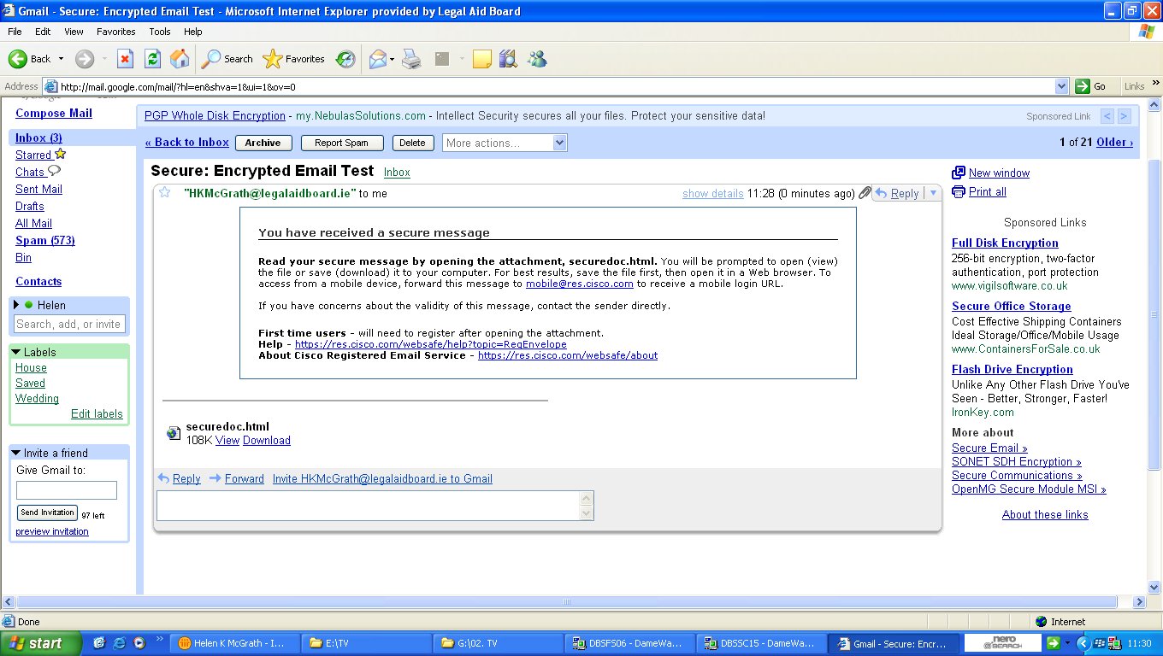

The first thing you must do is save the securedoc.html attachment to an accessible location i.e. your desktop.

When the file has been saved and opened you will see one of two screens depending on whether or not you are a first time user.

**Existing User Screen**

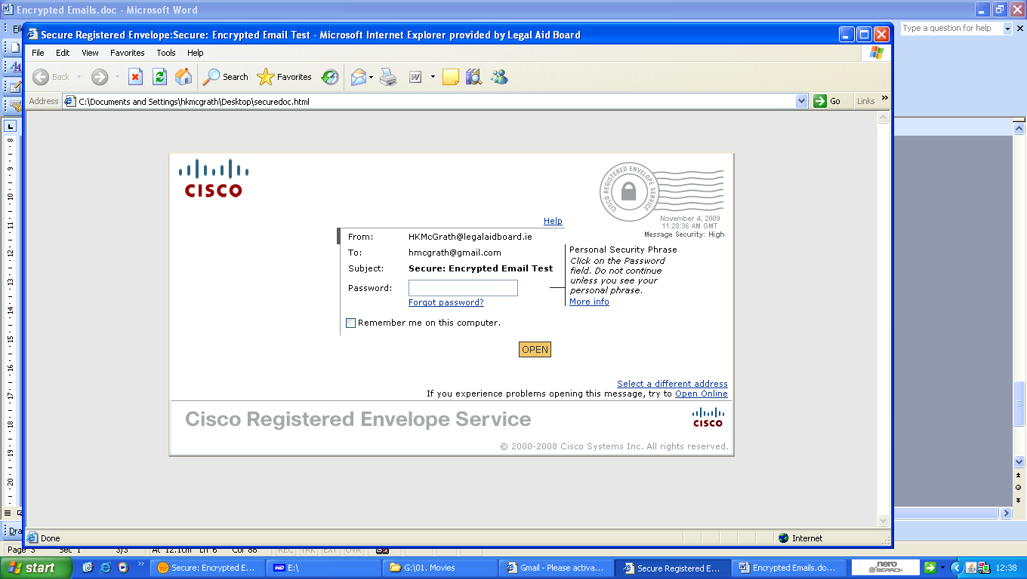

**First Time User Screen**

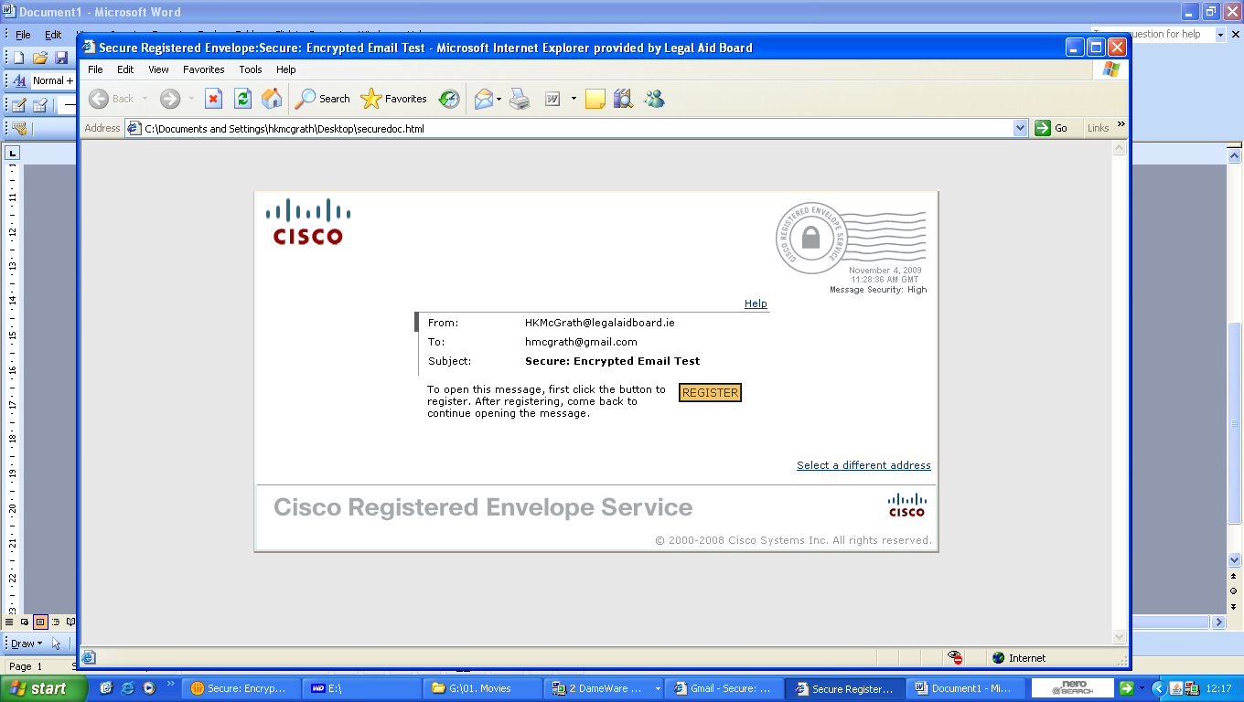

If you are an existing user enter your password and click the OPEN button and the encrypted email will be displayed. However, if you are a first time user you will have to register your details. To do this click the REGISTER button and complete the New User Registration form.

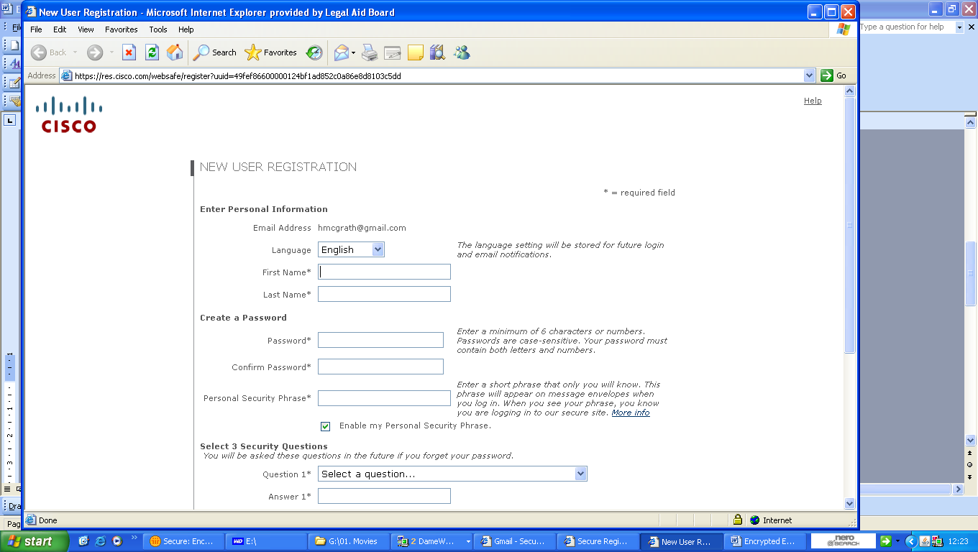

Once the registration form has been completed you must activate your account.

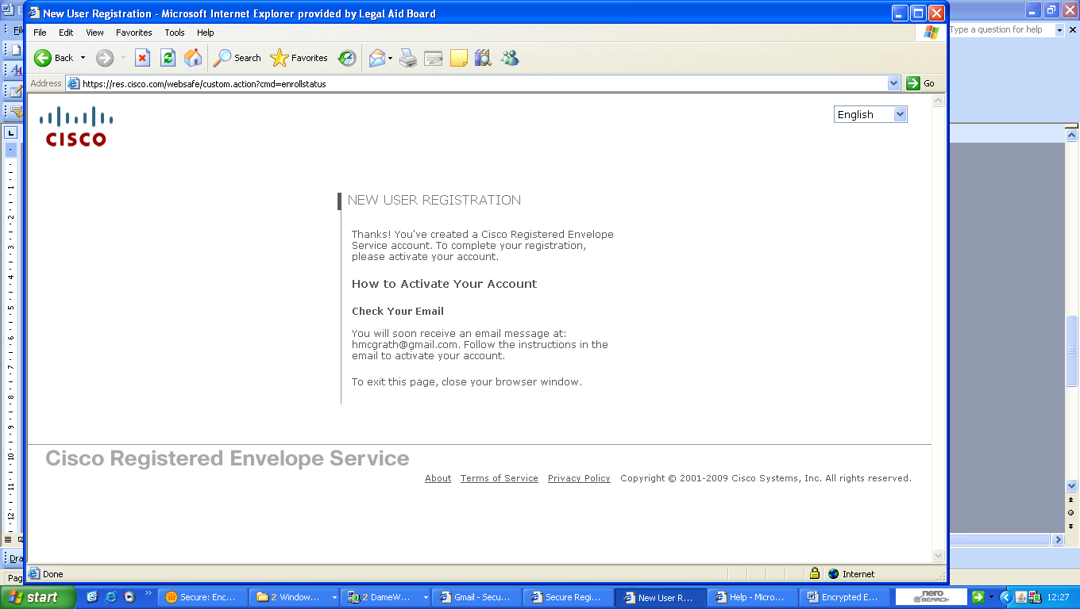

To do this, return to your Inbox and wait for an activation email from DoNotReply@res.cisco.com. Open the email and click on the blue ‘Click here to activate this account’ link.

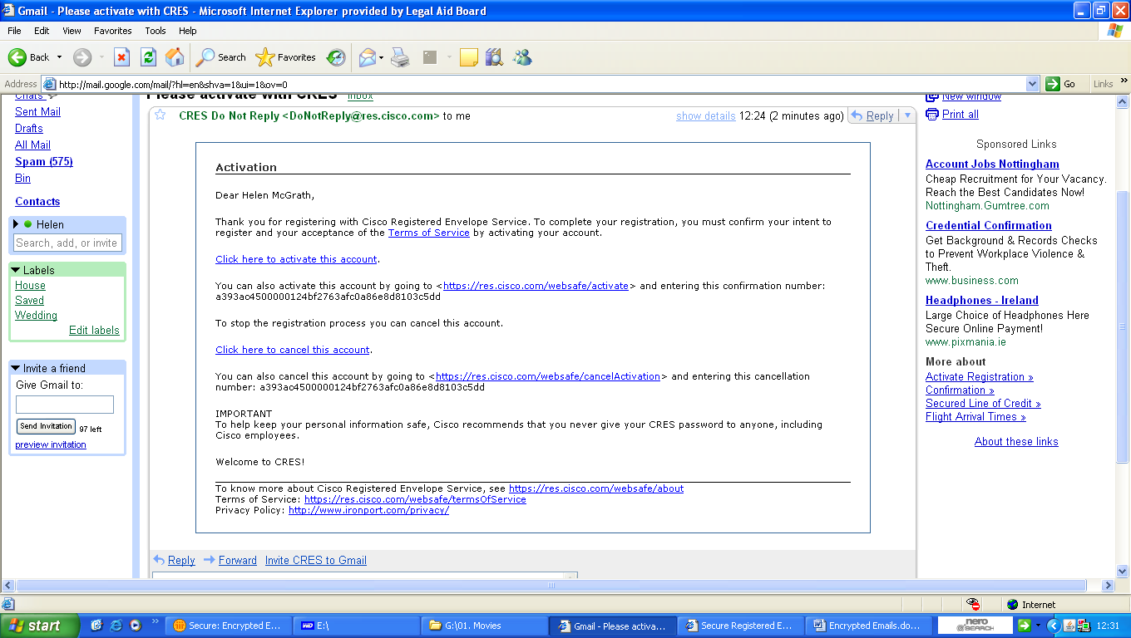

When your account has been activated return to the Cisco Registered Envelope Service page. If you have closed this page you can reopen it by double clicking the securedoc.html file you saved earlier.



Enter your password and click the OPEN button and the encrypted email will be displayed.

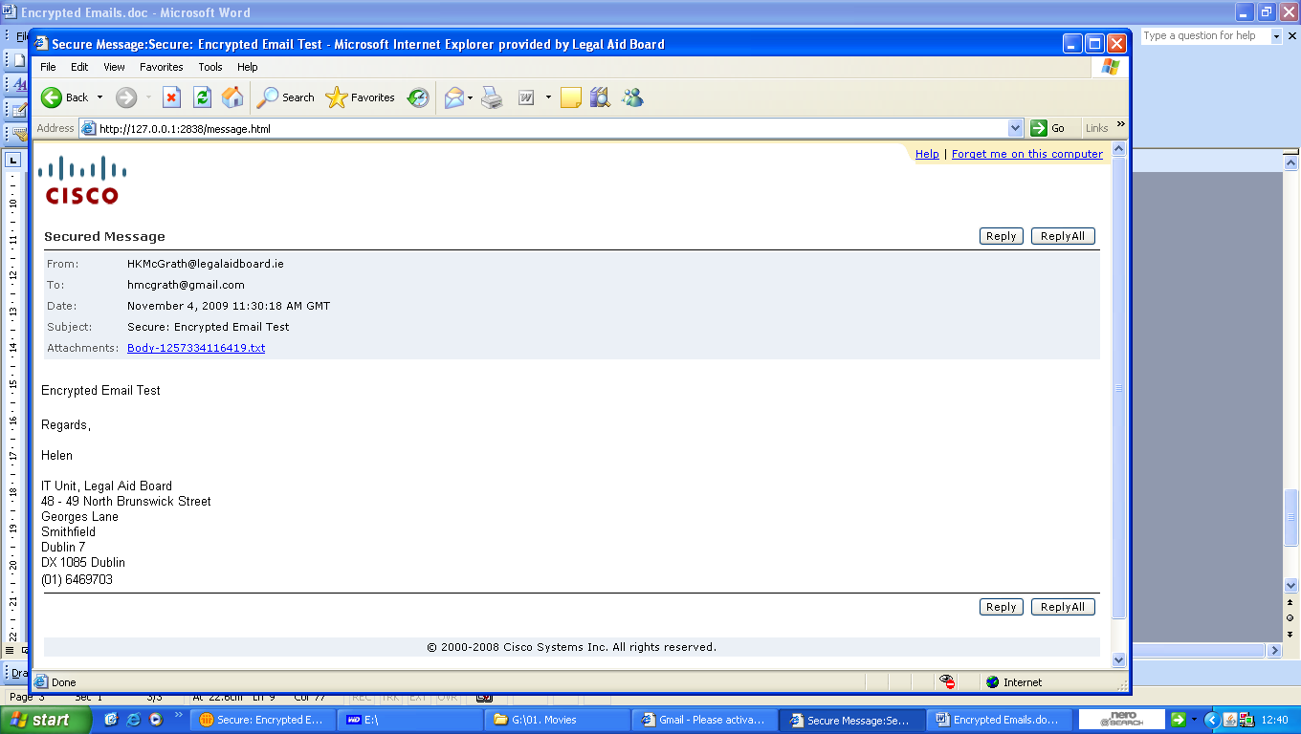

# **Appendix 3**

# **Best practice guidelines for child care cases**

This part of the Circular deals with best practice in relation to representing a Respondent in proceedings under the Child Care Act 1991, where the proceedings have been initiated by the Child and Family Agency (Tusla). These proceedings are conducted in the District Court.

This is a summary of the steps which commonly occur in a case where our client is defending an application for a Care Order (Interim/Full) or a Supervision Order. The proceedings are initiated by the Child and Family Agency and, once commenced, the process is controlled by the Court rather than the participants and, therefore, it is not possible to provide estimates of the timeframes for particular actions or Court Hearings.

Cases on foot of the Child Care Act 1991 are prioritised by the Board and persons who have been served with applications on foot of section 13 (Emergency Care order), 17 (Interim Care Order), Section 18 (Full Care Order) or Section 19 (Supervision Order) of the Act will be given the earliest possible appointment or referred to the solicitors panel. Every effort will be made to see him/her before the next court date. Where there are co-Respondents (usually the mother and the father of the child who is the subject of the application) it is generally considered to be in their best interests that each co-Respondent obtains separate legal representation.

***Stage 1: Pre Court***

The applicant will have been referred to the solicitors panel by the law centre and legal aid will have been granted.

The client may indicate they would like the solicitor to attend a case conference or case conferences organised by the Child and Family Agency. Do not attend such conferences other than in the most exceptional circumstances.

Request the client to bring all documentation that they have received from Tusla to their first consultation. Explain the nature of the documents that the client has received from Tusla. Explain the Court process and take instructions in relation to the factual detail and the recent history. Ask the client for a copy of any grounding affidavit sworn on behalf of Tusla.

If necessary, obtain the client’s written authority to enable information to be obtained from Tusla.

If an Emergency Care Order has already been made, write to Tusla’s solicitor requesting notes of the evidence given before the Court on foot of the ex parte application.

Keep the client informed of the process and what the potential outcomes or likely outcome will be.

It is generally the situation that Tusla applies to the Court initially for an Interim Care Order. This is a temporary Order that can only last for a maximum of 29 days, unless the client agrees to a longer period. There may actually be a number of Interim Orders sought until such time as the hearing for a Full Care Order is ready to take place.

Contact Tusla’s solicitor to get copies of social work, psychological and other reports and copies the notes of any case conferences that have taken place. Every effort should be made to get the documentation at the earliest possible opportunity.

Consider as to whether or not a replying affidavit (to the grounding affidavit) should be filed with the Court on the client’s behalf and, if so, furnish a copy to the solicitors for Tusla.

Discuss with the client that the Court is a ‘court of enquiry’ and that the Court’s considerations must have regard to the welfare of the child as the first and paramount consideration. Advise that the Court that it must give due consideration to the wishes of the child and have regard to the principle that it is generally in the best interest of a child to be brought up in his or her own family.

Upon receipt of the documentation from Tusla’s solicitor, review it with the client and particularly obtain his/her responses to the allegations including factual allegations being made by Tusla.

If care proceedings have been served upon the client and you feel that supervision proceedings might be an alternative, discuss with the client whether they might be willing to consent to a Supervision Order.

Take instructions as to whether the client wishes to contest the next court application, particularly if it is the first application at which they will have had legal representation. If the client wishes to contest the next application, make enquiries to ascertain what evidence might be available to support Tusla’s case. Discuss whether any members of the client’s family or other persons such as their GP or teachers may be of assistance to the case. Such persons, who it is considered can give evidence to benefit the client’s case, should be contacted in relation to assessing their assistance to the case and, if appropriate, their availability to give evidence.

Review the material that has been furnished by Tusla’s solicitor and determine, in consultation with the client if appropriate, what material, if any, can be submitted to the court in report form prior to the case commencing.

Ensure the client is aware that you will not be in a position to furnish them with copies of any reports that you obtain from Tusla as those reports are prepared exclusively for the Court and can only be released upon the direction of the Court. If for some reason, the client requires a copy of any report, then an appropriate application will need to be made to the Court for permission to release that document to the client.

Discuss with the client whether it is appropriate to apply to have a guardian ad litem appointed to represent the child/children. If it is considered appropriate to make such an application, identify possible persons who it is considered would be suitable to act as a guardian ad litem. In considering their suitability have regard to the contents of the Children Acts Advisory Board publication Giving a voice to children’s wishes feelings and interests. This document sets out, among other things, the standards for qualification for a guardian ad litem. In such circumstances, liaise with Tusla’s solicitor to ascertain if the appointment of a (particular) guardian ad litem can be agreed. It will, however, be a matter for the Court to decide whether such a guardian should be appointed and who that will be.

Contact should be made with Tusla to see if there is any prospect of reaching a settlement that is mutually acceptable to the client and Tusla and discuss this with the client. Every effort should be made to see if a satisfactory agreement can be reached without the necessity of any further contested Court Hearings. Particular regard should be had to whether it might be possible to resolve the matter by agreeing to a Supervision Order on that basis that any application for a Care Order would be struck out or would be adjourned for a period of time without any such Care Order being put in place.

***Stage 2: Pre Court Hearing***

Following any interim hearing, discuss with the client the development of a longer term strategy for the conduct of the case. Potential expert witnesses might be identified and enquiries made whether they can undertake an assessment and prepare a report that might be helpful to the client’s case. Any such witnesses should have a speciality that will be able to give an expert opinion on an issue that is central to the case. Legal aid authority must be sought in advance for the payment of their fees. Any such expert witnesses will have to be fully and properly briefed to include a comprehensive letter of instruction.

Give careful consideration as to whether all relevant material has been made available by Tusla including whether all social work files have been made available. An application for discovery may have to be made. In the absence of an application for discovery, a request under the Freedom of Information legislation can be considered.

If a guardian ad litem has been appointed then, if appropriate, make contact with Tusla’s solicitor with a view to agreeing a joint letter to the guardian giving relevant background information.

If there has been a contested hearing at an earlier application for an interim care order and if there is no significant change in circumstances, you may (if appropriate) advise the client that there is little to be gained by contesting further interim applications and that it may be in their best interests not to contest further interim applications and instead to concentrate on addressing the issues or concerns that gave rise to the proceedings. Discuss this with the client and take instructions.

If a guardian ad litem has been appointed then make contact with the guardian’s solicitor seeking copies of any reports prepared by the guardian for submission to the Court. Similar to Tusla reports, we will not be in a position to release copies of any of these reports to the client but you should discuss them in detail.

Prior to the matter coming on for full hearing, efforts should be made with the Tusla solicitor to agree the evidence that may be agreed and, if possible, narrow the issues in dispute. It is recognised that because of the nature of the proceedings it may be difficult to narrow the issues. A check should also be made in relation to the availability of expert witnesses that may be called.

***Stage 3: Court Hearing (Interim Order/Full Order)***

Take final instructions from the client prior to the commencement of the hearing. If any further reports have been furnished late in the day then discuss the content of these reports with the client and ask him/her for their views on the contents. If there are substantial amounts of new material made available just before the Court discuss with the client whether an adjournment of the matter should be sought to enable you to properly consider and discuss with you the details in this material.

The proceedings are heard by the Court in private. Only those parties connected with the proceedings can attend the Court. If is possible that the Judge will allow an accredited journalist to sit in and report on the proceedings. Any Court report, however, cannot identify the client, the children or the other parties involved.

Tusla present their case first. Tusla’s lawyer will outline the circumstances and history for the Court and then call the witnesses that they will be relying upon in seeking the Order from the Court. If appropriate, cross-examine Tusla’s witnesses. If there is a guardian ad litem then the guardian will give evidence and, if appropriate, may be cross-examined.

Throughout the hearing regard should be had to the strength of your case, bearing in mind the evidence that will be presented to the Court by Tusla. In quite a lot of Child Care cases, the reality is that the ‘high point’ of a Respondent’s case may well be reached at the conclusion of Tusla’s presentation of their evidence. At that point, you may need to discuss with the client whether putting him/her in the witness box to give evidence is likely to further their case. The decision on whether or not the client is to give evidence is their own. The option of not calling a client is something to be seriously considered only where the Tusla evidence is particularly weak and/or the client’s evidence is most likely not to be helpful.

If the client wishes to contest any evidence given on the part of Tusla then they will need to give evidence and will do so at that point. The client will then be cross examined by Tusla’s lawyers.

In recent times the solicitor for the Guardian has also engaged in cross examination but the legal basis for this is not beyond question. Any witnesses on their behalf will then give their evidence and they too will be subject to cross-examination by Tusla’s lawyer and, if appropriate, the guardian’s lawyer.

Upon hearing all the evidence, the Court may make a number of Orders. If it is an application for a Care Order (Interim or Full), the Court may say that it is not satisfied that the necessary threshold of evidence has been reached and dismiss the application or, in some circumstances, it may say that while it will not make a Care Order, it is appropriate to make a Supervision Order. If the Court makes an Interim Care Order then it will do so for the appropriate period of time and put the matter in for further hearing. The Court may grant a full Care Order for such period of time as it feels appropriate up until the child’s 18th birthday. Often a court may make an order for a shorter period to give parents some prospect of being reunited when they have addressed Tusla’s concerns. Alternatively, the Court may make no order and adjourn the matter to a later date for further consideration.

When the Court gives its decision, discuss with the client whether an application should be made to have the case reviewed at a later date.

Discuss with the client whether a request should be made to the Court to make a direction that the matter come back before the court in the event of any significant change in the child protection plan for example any change of the particular foster placement.

***Stage 4: Post hearing***

At the conclusion of the case, advise the client of the decision; any review dates that are set by the Court; the possibility of seeking to discharge, at some point in the future, any Order that might be made if there is a change in circumstances at that time; the possibility of appealing and the merit or otherwise of doing so; the steps that it is considered the client might take in order to improve their circumstances; the need to remain engaged with Tusla in relation to access and the possibility of making an application to the Court for access if suitable arrangements cannot be agreed with Tusla.

***General***

Throughout the course of the case, keep the client informed informally and in writing of developments, including Court dates. It will greatly assist if the client responds punctually to all requests for instructions and information relating to the case and attends for consultations when requested and attends the Court Hearings.

**Arrangements to appoint persons to assist clients of impaired capacity in child care proceedings**

This part of the Circular applies only to clients who are Respondent parents in child care proceedings.

The purpose of appointing a person to assist clients of impaired capacity (being Respondent parents in child care proceedings) is to ensure the provision of an effective legal aid service to the client. The client must have some capacity, but the solicitor must be of the opinion that the capacity is so impaired that it is essential that the solicitor have professional assistance to communicate effectively with the client in relation to the subject matter of the proceedings. The person is often described as an “advocate” though the use of such a description is not meant to imply any role for such a person in relation to advocacy on the Respondent parent’s behalf in Court.

***Circumstances in which such a person might be appointed***

It is difficult to be definitive as to the range of circumstances in which a solicitor might be required to make an application to have a person appointed to assist and support a client. It is possible that this form of assistance may be required, for example, in a childcare matter and, if so, if it is envisaged that this person is to be furnished with social work reports or other reports connected to the proceedings then application will have to made to the Court in advance seeking authority for these reports to be furnished to the person and for permission for that person to sit in on the proceedings with the client. Regard must be had to the particular circumstances of a client and the case and also to the availability of a suitably qualified / experienced person to assist.

The following are some of the factors that ought to be considered when determining whether an application ought to be made:

whether the client has a previously diagnosed psychiatric or psychological impairment or learning disability

the available evidence of such condition

the client’s level of comprehension in relation to the proceedings and the potential outcomes

the level of family or other support that is available to the client

the solicitor’s relationship with the client

any negative connotations that the appointment of such a person might have in relation to their defence of the application by the Child and Family Agency

the likely availability of a suitable person to assist

***Decision making in such cases***

The solicitor must apply to the Board for authority to appoint a person. The application must address:

* The circumstances in which the person is being appointed
* The reasons why a person needs to be appointed. This **must** address the applicant’s lack of capacity.
* The identity of the person to be appointed and their qualifications, including a statement that the person is willing to work under the Board’s terms and conditions and for the funding rate involved (see below).

All persons enjoy the presumption of capacity. Some evidence must be tendered to the Board that there is a lack of capacity (but not no capacity)

***The criteria for making a decision on such an application***

An application for the appointment of a person to assist a client will be treated as an application for an amendment to a legal aid certificate. The provisions of the Act and Regulations will apply to such an application. Of particular relevance is Regulation 9(1) which authorises us to amend a certificate “if it appears to be necessary in the particular circumstances of the case to do so”.

For a decision maker the test is as set out in the first paragraph of this part of the Circular – that is, that **the decision maker considers that the person’s capacity is so impaired that it is essential that the solicitor have professional assistance to communicate effectively with the client in relation to the subject matter of the proceedings.** If the decision maker considers this test to be met, he or she should approve the application by way of amending the legal aid certificate. The grant should be subject to the appointed person signifying their acceptance of the terms and conditions.

In coming to this decision, the decision maker should consider the following factors:

whether the client has a previously diagnosed psychiatric or psychological impairment or learning disability (including any evidence of same that the solicitor has tendered)

the client’s level of comprehension in relation to the proceedings and the potential outcomes

the level of family or other support that is available to the client

the suitability of the person whom is proposed, including having appropriate qualifications

***The role of the person so appointed***

The general role of such a person is to provide assistance and support to the client, in the context of the solicitor and the legal proceedings. Ultimately the purpose of appointing such a person is to ensure the provision of an effective legal aid service to the client.

The person will not be acting as a guardian ad litem and will not be giving instructions to the solicitor. If there is any disagreement between the person so appointed and the client, the solicitor is obliged to act in accordance with the client’s instructions. Having regard to this, it is envisaged that the person’s role will be:

To facilitate clients in understanding and participating in Court proceedings. To amplify a client’s ability to fully participate in the proceedings.

To facilitate client in understanding Court reports and in relaying the clients view and wishes to their solicitor/ barrister.

To attend consultations between the client and solicitor/ barrister as required. To advise solicitor/ barrister of any difficulties client is having in understanding or processing information and/or advices given. To advise solicitor/ barrister of any impediments a client has in processing information and advices given and how these might be overcome.

To attend court hearings with the client and solicitor/ barrister and assist client in understanding evidence being given and representations being made. To advise solicitor/ barrister if client requires a break or is struggling to understand Court proceedings. To relay any difficulties client has in understanding proceedings to solicitor/ barrister during proceedings.

To attend other professional/ inter disciplinary meetings with the client when specifically requested to do so by the client’s solicitor/ barrister or the Court. To advise professionals at these meeting of any difficulties client is having in understanding or processing information and advices given. To advise professionals at meeting of any impediments a client might have in processing information and advices given and how these might be overcome.

To attend assessments a client might undergo when specifically requested to do so by the solicitor/ barrister. To advise assessor of any difficulties client is having in understanding or processing information and advices given. To advise assessor of any impediments a client might have in processing information and advices given and how these might be overcome.

To relay information from the solicitor/ barrister to the client in a clear and accurate manner. To ensure client understands same. To relay client’s views and instructions to the solicitor/ barrister.

To assist in explaining to the client the nature of the proceedings and the potential outcomes as directed by solicitor/ barrister. It is not the role of the person appointed to offer a legal advice to the client, but to facilitate the legal advices of their solicitor/ barrister to be conveyed to client with reference to that client’s level of understanding.

To enable the person appointed to perform their functions effectively it is envisaged that the person would sit in on at least some consultations with the client.

***The criteria for identifying suitable persons to provide assistance***

The person to be appointed must have some level of speciality/professional expertise and must not be personally connected to the client. It is considered that qualifications / experience in for example social work, psychology, and psychiatry would establish suitability in many cases. These examples are by no means exhaustive and there may be other specialities that can offer meaningful assistance and support depending on the particular circumstances of the case.

***Fees and expenses***

The Board will pay fees and expenses incurred by any person appointed under these arrangements, on the basis of an hourly rate where the person:

attends with the client and/or the solicitor at court hearings

attends at consultations between the client and solicitor

attends with the client on other occasions when specifically requested to do so by the solicitor and where the solicitor certifies that the attendance was essential and was approved in advance by the solicitor

The solicitor should explain clearly that the appointment is for a limited number of hours and that the solicitor will be keeping track of the number of hours the person is engaged for and the person should do the same. Without prejudice to the discretion of decision makers, it is envisaged that each appointment should be for an initial block of ten hours at a rate of €65 per hour, though a solicitor may apply for further funding. This arrangement has regard to the very specific functions to be performed by the appointed person.

The following arrangements will apply in relation to travel and subsistence to persons appointed on or after 30th April 2019:

* Solicitors are in the first instance required to attempt to engage such a person who is geographically located close to the solicitor’s office before considering engaging a person located a considerable distance from the solicitor’s office.
* Notwithstanding the above, and having regard to the difficulties in obtaining locally based persons in certain areas, motor travel expenses will be paid at a flat rate of €0.42 per km. Alternatively the Board will reimburse the actual vouched price of a standard class public transport ticket.
* However, travel expenses will not be paid to any Dublin-based person with respect attendances at court venues or other places in the Dublin Metropolitan District. A person will be regarded as “Dublin-based” if **either** their home or their place of business where they are normally headquartered is located in Dublin city or the areas of Fingal, South Dublin, or Dun Laoghaire Rathdown.
* Subject to the above conditions, the rules regarding travel applying to civil servants at the time the person is engaged as set out in the Department of the Public Service Circular 11/82 and any circular supplementing or revising that Circular are applicable.
* Subsistence expenses are not payable in any circumstances.

Claims must be submitted using the appropriate claim form which is attached to the terms and conditions which can be obtained from the Board.

***Requirement of person appointed to accept terms and conditions***

All persons appointed to assist Respondent parents in child care proceedings must accept the terms and conditions of appointment including the funding conditions. The terms and conditions must be obtained from the Board and explained to the person appointed before their appointment proceeds.

It must be particularly emphasised to an appointed person when accepting the terms and conditions:

that they may not give instructions to a solicitor on behalf of a legally aided person, even if they feel a particular course of action is in the person’s best interests

that, notwithstanding the use of the description “advocate” to refer to such a person, it is the role of the lawyer, who enjoys a right of audience before the court, to act as advocate in the context of court proceedings.

that the *in camera* rule applies and its practical effects.

The person must sign the terms and conditions to indicate their acceptance. A copy of the signed terms and conditions should be returned to the Board.

***Application of the above arrangements***

The above particular arrangements are intended to apply only to the defence of applications by Tusla for a care order or supervision order.

These arrangements are not intended to provide for payment for persons who might be providing assistance and support to a client in any event.

# **Appendix 4**

# **Claim Form**

|  |  |
| --- | --- |
| **PUBLIC LAW CHILD CARE SOLICITORS PANEL**  **Claim for Fees** |  |
| A complete claim form must be accompanied by a copy of the legal aid certificate or other written authority (in the case of additional services)  Please email to [localpp@legalaidboard.ie](mailto:localpp@legalaidboard.ie) | |

SECTION A

**Case details**

|  |  |  |
| --- | --- | --- |
| 1. | Solicitor |  |
| 2. | Email |  |
| 3. | Client Name |  |
| 4. | LAB Case No |  |
| 5. | I have briefed a barrister | Yes  No |

**Particulars of claim**

|  |  |  |  |
| --- | --- | --- | --- |
|  | Dates of hearing | Time spent (Refreshers / Reviews only) | Fee claimed |
| **Case fee**:- to cover all work carried out by him or her in regard to the case to include as appropriate, consultations, preparatory work, settlement negotiations and/or court appearances incidental to the full hearing. |  |  |  |
| First application for an interim care order |  |  |  |
| Each subsequent application for an interim care order |  |  |  |
| Refresher fee for second or subsequent day of a hearing, or part thereof (where applicable – see fee schedule for details) |  |  |  |
| Review of full care order |  |  |  |
| Other application to the Court (of the nature set out in Schedule 1 and not being an application for access) made during the currency of proceedings and subject to the matter involving legal submissions and / or evidence in excess of thirty minutes. |  |  |  |

SECTION B

**Details of case outcome**

Please set out details of the outcome of the case (e.g. Supervision Order granted, Care Order granted, children returned to parents, voluntary care arrangement etc).

|  |
| --- |
|  |

SECTION C

**Certification of claim**

I certify that I have provided the legal services as set out and I accordingly seek payment of the

appropriate fee in accordance with the terms and conditions for the provision of legal services under the Terms and Conditions of the Public Law Child Care Solicitors Panel

|  |  |  |  |  |
| --- | --- | --- | --- | --- |
| Signature |  |  | Date |  |
| Liable for VAT | Yes  No |  | VAT No. |  |

**For Legal Aid Board use only:**

|  |  |  |
| --- | --- | --- |
|  | Authorised Officer | Date |
| Received by |  |  |